Unit Testing Mash Up Loan Application

1. Initial Screen (using Dark mode from tailwind)

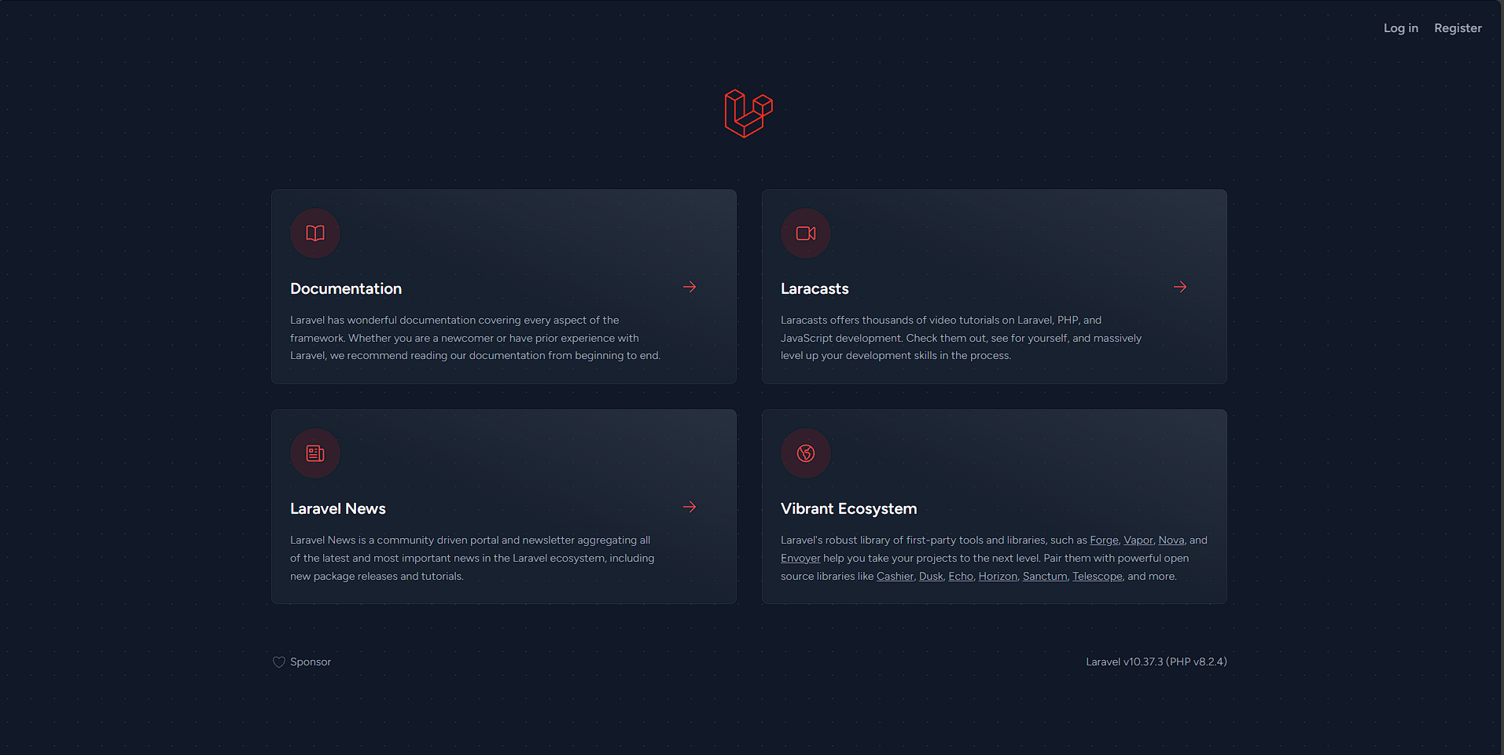

Here is the default initial screen from laravel, on top right is Log In and Register buttons

1. Register

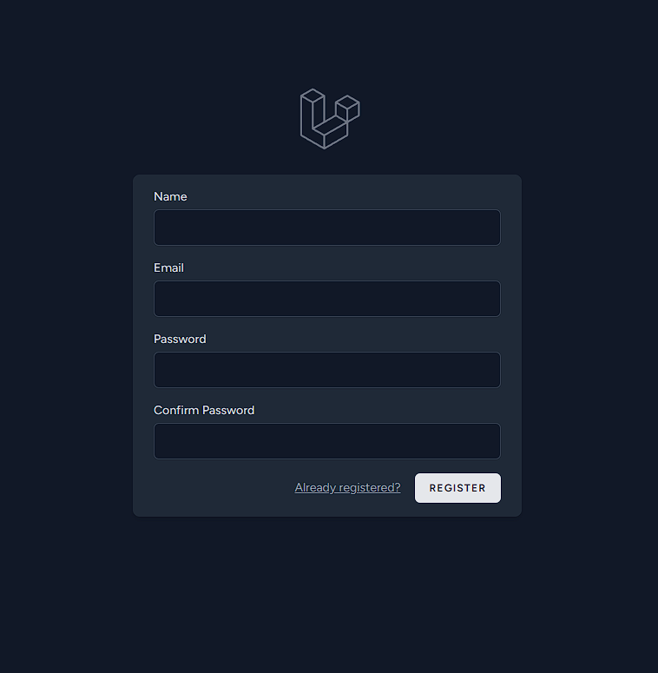  
this is the Register screen, provided by Laravel Breeze, along with Login and its authentication

1. Log In

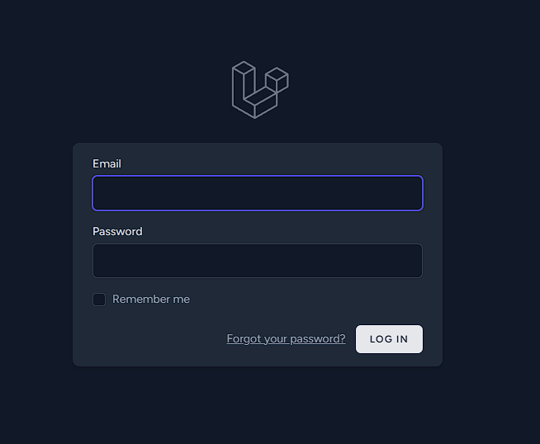

The Log In screen provided by Laravel breeze, along with its authentication

1. User Screen

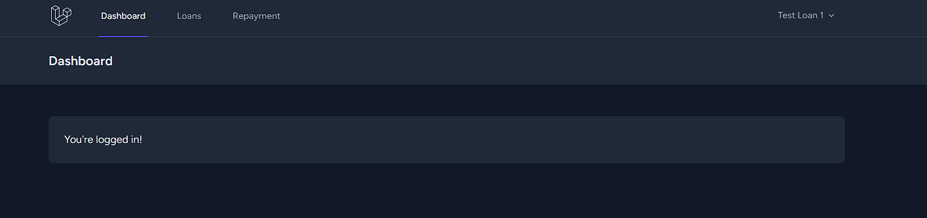

Default screen when first logged in, as normal user, on navigation pane are Loans and Repayment

1. Loans

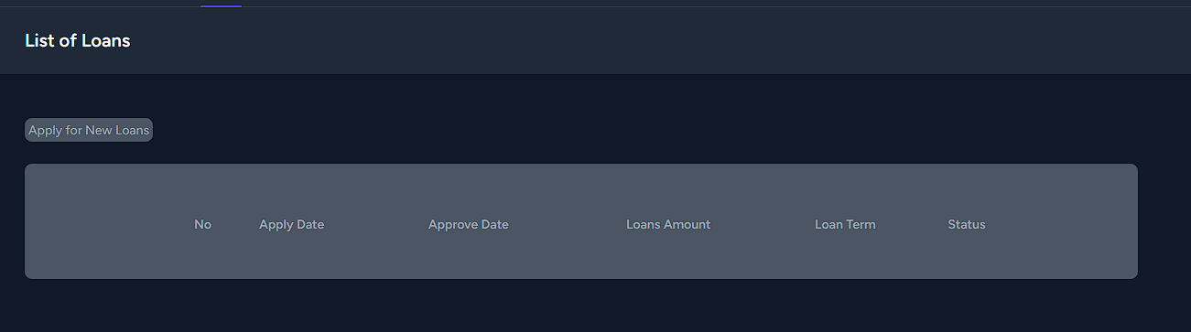

This is the screen for Loans, to lists all the loans from current user and to apply for new loans

1. Repayment

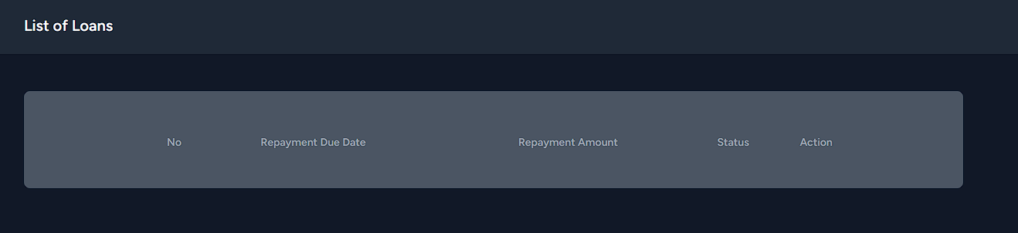

This is the repayment screen, listing all loans approved by Admin and are yet to be paid back

1. Add Balance

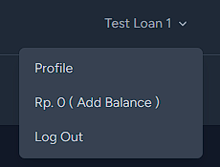

This is the button to add balance and view your current balance which are used to pay the loans

1. Loans Approval

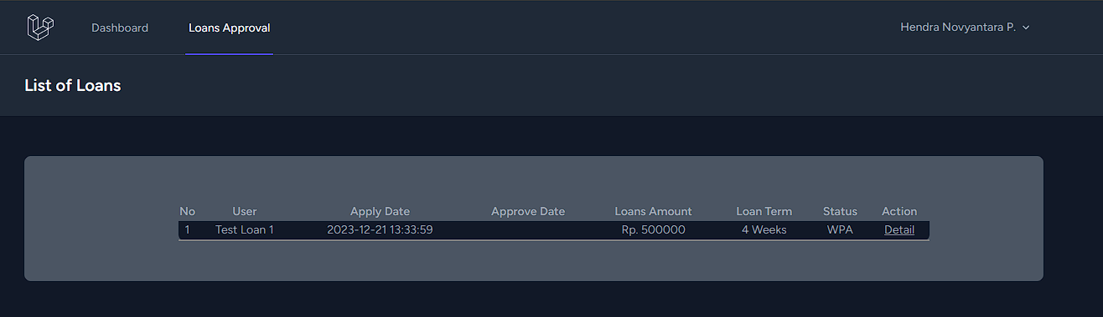

Admin Screen for Approving Loans or viewing the detail

Test Case

- Apply for Loans

1. As Normal User, Apply for New Loans

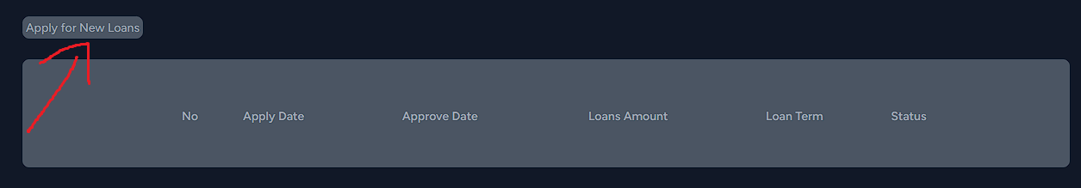

1. Choose the Loan Amount and the Loan Term (in this test case, amount is 500000 and term is 4 weeks), then click Apply

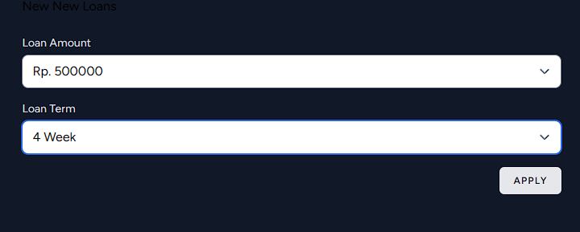

1. New Loans now waiting for approval from Admin

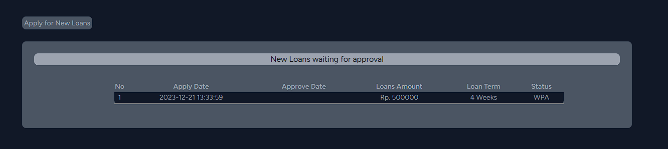

- Approving Newly Applied Loans

1. Log In as Admin, then go to Loans Approval Screen



1. Click on the Detail of the Loans, then click on Approve

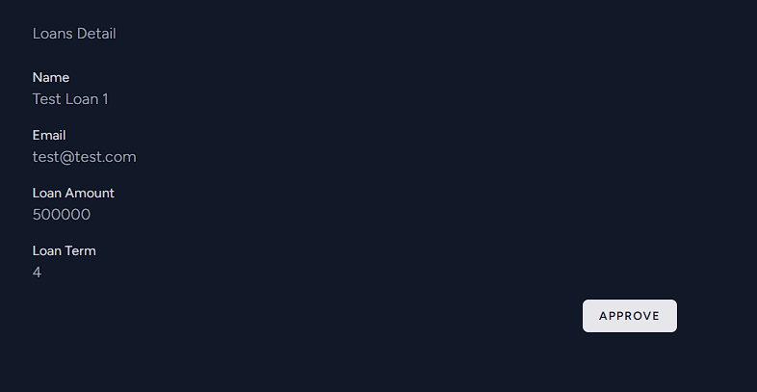

1. Loans Approved

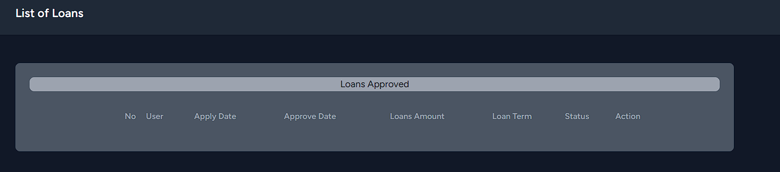

- Adding Balance

1. As Normal User, on any screens, click on top right button which displays account name

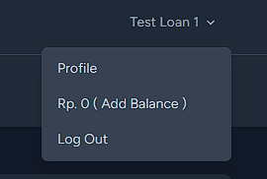

1. Click on Add Balance, which then will add 500000 to your balance

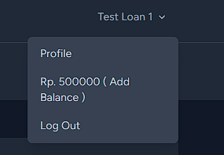

1. S, this made this way just for the sake of easier testing

- Loans Repayment

1. As Normal User, go to Repayment screen

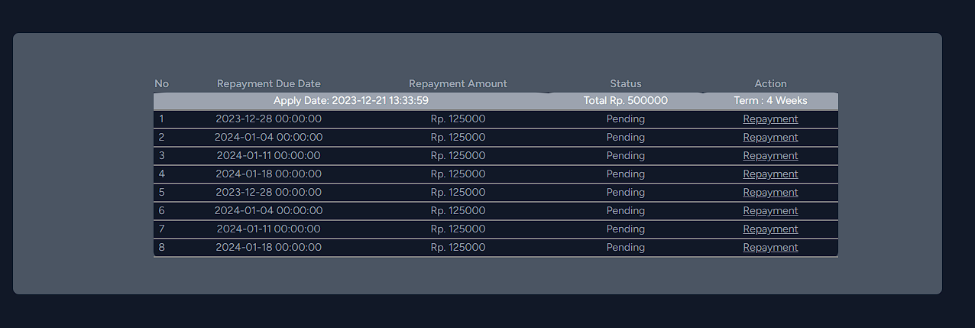

1. Click on repayment of any rows ( there are no validations or checks which rows should be done first)

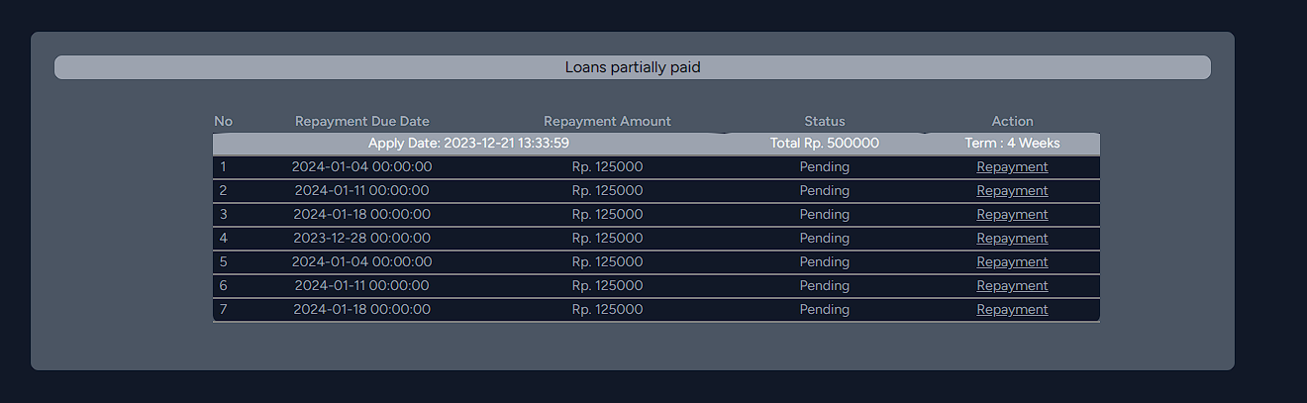

1. There will be message displaying Loans partially paid and the rows paid are gone
2. If all of the repayment are paid, then the message displayed will be “Loans fully paid”

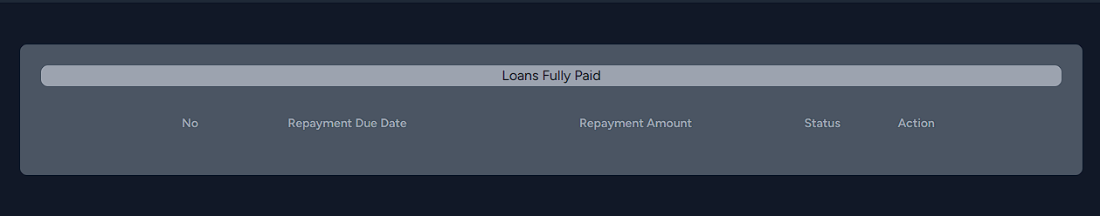

P.S, during this test case, there are 8 rows displayed instead of 8, this is because the Loans are approved twice due to re-capture the screen of previous test case